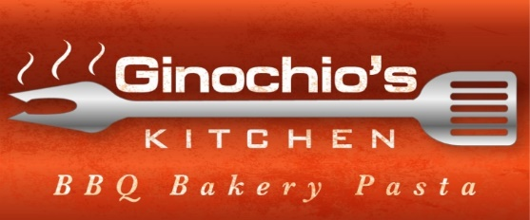
Catering Offerings
Breakfast

Bacon or Steak Burrito $15
Beef Brisket Hash with Scrambled eggs $15
Quiche – Bacon & Cheese or Vegetable $7
Caramel Bacon Monkey Bread or Cinnamon Rolls $5
Yogurt, Granola & Berries $8

Appetizers

Assorted Fruit Tray with Yogurt Dip $5
Assorted Vegetable Tray with Hummus Dip $5
Assorted Local Cheese, Crackers, Nuts & fruit Tray $5
Chips & Salsa $3
BBQ Pulled Pork Sliders (2) – $8

Main

BBQ Chicken, Smoked Pulled Pork, Smoked Beef Brisket or BBQ Tri-Tip Steak Sandwich $15
Meat or Vegetarian Lasagna $12 (minimum 6 servings per order)
Fish Tacos – Grilled with slaw, chipotle drizzle & mango salsa $15
Local, Organic, Grass Fed Burger with cheese $15 or Veggie Pattie $10
Meat Raviolis & sauce $12
Smoked Pork Ribs $20

Holiday or Special Events
Smoked or BBQ Whole Turkey, Ham, Pork, Fish or Prime Rib – Market Price

Sides & Salads
Caesar or Green Salad $5
Vegetarian or Meat Country Ranch Beans $5
Chilled Broccoli Salad with Almonds, Raisins, Sunflower Seeds $5
Grilled Assorted Vegetables $5
Crusty Sourdough Garlic & Parmesan Bread or Focaccia $5
Country Ranch Beans $4

Dessert
Brownies: Just Chocolate or Coconut Chocolate Brownies $3
Cookies of Many Kinds: Chip, Oatmeal, Sugar or Monster $3
Seasonal: Crumb & Lattice Whole Pies or Crisps $5
Coffee, Cream & Sugar $5
Drinks
Canned Soda (Coke, Diet Coke, Sprite or Root Beer), Bottled Water, Bottle Iced tea or Lemonade $5 (Ice & Cooler Extra)
Other
Pricing is Per Person except whole Holiday offerings
Served Family Style
Staff: $30 per hour Per Staff, 1 per 25 guests recommended: Set-up, Bar Service, Serve Buffet, After-Dinner Clean-up, After Event Clean-up
Dinnerware: Knives, spoons, forks, paper plates, plastic cups $3 PP
Drop off, Chafing Dishes or Served Buffet: Priced per event
Chafing Dish Rental: $25 per chafing dish
Tastings: $40 Per Person (Choice of 6) 50% Refunded upon signing agreement
Payment: Upon Confirmation Booking – 50%
Final Payment: Due 14 days prior to event date
Final Guest Count: Due 14 days prior to event
Minimum Order $500
Delivery Charges Vary
On-Site BBQ in Bodega Bay $275
On-site BBQ Team (2): $90 per hour
Plus required Taxes & 18% Gratuity
Pricing subject to change without notice

Ginochio’s Kitchen, 1410 Bay Flat Road, Bodega Bay, CA 94923 707-377-4359 www.ginochioskitchen.com Email: ginochioskitchen@gmail.com
Dated 11-28-16

